**UMESH LALUPRASAD MISHRA**

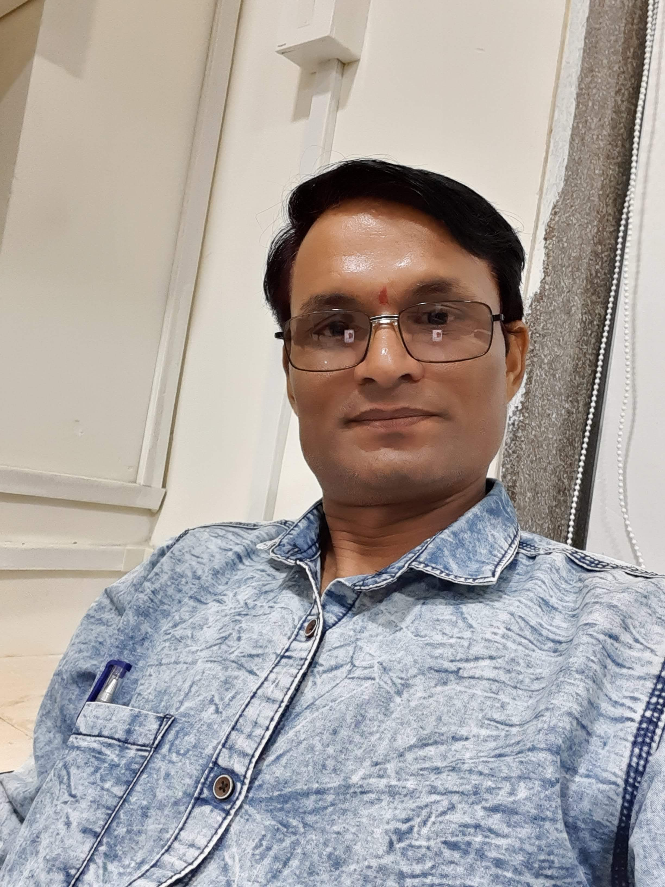

**Permanent & Correspondence Address :**

C/O Shri Lalluprasad S. Mishra

At-Po-Kamtha,

Tah /.Distt.- Gondia (M.S.) - 441601

Mobile No: **08888117577 / 08855095597**

E-mail: ***[umeshmishra1981@gmail.com](mailto:umeshmishra1981@gmail.com" \t "_blank) , umesh.intertek@gmail.com***

**Date of birth**  : 20 - 12 - 1981

**Education** : Diploma in Civil Engineering from Mumbai Board, Year March 2002

**TOTAL PROFESSIONAL EXPERIENCE 14 YEARS**

**December 2019 to February 2021**

M. M. K. Enterprises (A 'KUSHAL' group company)

**POSITION: Site Engineer (Civil)**

**CLIENT: Aegis Logistics LTD (LPG Storage Plant) Kandla Gujarat**

**Responsibility at present jobs:**

Job Planning, Monitoring, Expediting, and report preparation. Drawing related along with Day-to-day technical problems solving. Preparation and certification of various reports, Verification and certification of various Construction drawings submitted by Contractors. Co-ordination with other section Like Designing, Engineering, Civil, Piping, Electrical substation control room, Electrical, tank foundation with filling and compact bases (Tank foundation 52 mit.@ RCC columns) and elections Instrumentation. To guide and lead the subordinates. Supervising and monitoring the work force and guide for execution of Civil works. Incoming material Inspection, ensuring proper protection of Structures. Painting and other finishing jobs, Bill certification, drawing study, checking, preparation of work as per drawing, Physical verification and measurement certification.

**INTERTEK INDIA PVT. LTD (TPI)**

**POSITION: Site Engineer (Civil)**

**CLIENT: Hindustan Petroleum Corporation Limited (LPG Plant)**

**PROJECT: HPCL LPG Bottling plant, Jamshedpur, Jharkhand India**

**Responsibility at present jobs:**

Site Supervision, Quality Control at Site, Safety Control at Site, Checking out of Documents & Certify it (i.e. IMIR for all materials inside Installation),Checking out & Certify Documents of Procedure For Survey, Site Grading, Earthwork in Excavation, PCC and RCC, Brick Masonry, Plastering, and Compound Prefabricated Structures,(LPG Storage shed, Parking shed,Gantry shed, and LPG Filling shed) Coordinating with client for Inspection, Tests, Quality Assurance Plan, Project Implementation Procedure, Cost Control, Progress Measurement & Report, Handing over & Closure of Site, Documentation, Assistance in Arbitration, Audits. Planning, Organizing & controlling the project for timely execution of Project Take corrective action in case of any deviation to correct the project path, Develop & Update Project Bar Chart for each location, Timely decisions for smooth progress of the work. Regular Quality & Safety Audits, once in every quarter, at each location during Project Execution, Receiving and reviewing invoices and administering/certifying payment.

**August 2013 to July 2017**

**Triune Energy Services Pvt. Ltd (PMC)**

**POSITION: Construction Engineer (Civil)**

**CLIENT: Hindustan Petroleum Corporation Limited**

**PROJECT: MDPL terminal Project, Mundra, Gujarat and**

**HPCL Mumbai Refinery Chembur Mumbai**

**Responsibility at present jobs:**

Tests, Quality Assurance Plan Pile Foundation Project Implementation Procedure, Cost Control, Progress Measurement & Report, Handing over & Closure of Site, Documentation, Assistance in Arbitration, Audits. Planning, Organizing & controlling the project for timely execution of Project Take corrective action in case of any deviation to correct the project path, Develop & Update Project Bar Chart for each location, Timely decisions for smooth progress of the work. Regular Quality & Safety Audits, once in every quarter, at each location during Project Execution, Receiving and reviewing invoices and administering/certifying payment

Site Supervision, Quality Control at Site, Safety Control at Site, Taking Measurements & Certification of RA Bills as per CLIENT, forms/formats & forwarding to CLIENT for processing payment to the contractors by CLIENT, Site Documentation. Overall Project Management Services, Design, Drawings, Document Approval, Witnessing & Approving Factory Acceptances Tests & Site Acceptance (Building like MCC room , Sheds like Fire pump house, fire water tank foundation, pile foundation, Control room ,DG, Compressor shed, Excavation, Industrial & Warehouse Sheds, Roofing PCC and RCC, Brick Masonry, Plastering , Panting and All civil works.) And Civil Foundations work like (Structures foundation PCC,RCC, and pile Foundation Flooring, cable tranche, Roof Slab (Ducting Sheet Slab) and Pump Foundation etc. IMIR Report and Material inspection with client.

Tests, Quality Assurance Plan, Project Implementation Procedure, Cost Control, Progress Measurement & Report, Handing over & Closure of Site, Documentation, Assistance in Arbitration, Audits. Planning, Organizing & controlling the project for timely execution of Project Take corrective action in case of any deviation to correct the project path, Develop & Update Project Bar Chart for each location, Timely decisions for smooth progress of the work. Regular Quality & Safety Audits, once in every quarter, at each location during Project Execution, Receiving and reviewing invoices and administering/certifying payment to

Contractors.

**Oct-2010 to date Jun-2013**

**Velosi CERTIFICATION Services (I) Pvt. LTd**

**POSITION: INSPECTION ENGINEER (TPI)**

**CLIENT: OIL&NATURAL GAS CORPCORPORATIO**

**PROJECT: ASSAM RENEWAL PROJECT GROUP A**

**Responsibility at present jobs:**

Checking out of Documents & Certify it (i.e. IMIR for all materials inside Installation),Checking out & Certify Documents of Job Procedure For Survey, Site Grading, Earthwork in Excavation, PCC and RCC, Brick Masonry, Plastering, and Compound Wall, Coordinating with client for Inspection, Foundation, Boundary Wall, Electrical foundation and sub stations etc, Material inspection & Reviewing of Test Certificates, Coordinate with subcontractor.

**Aug 2008 to Sep 2010.**

**IOT Infrastructure & Energy Services Ltd.**

**103, Spectra, Hiranandani Business Park , Powai , Mumbai 400 076**

## **Project- BSPL terminal Project, Viramgam , Gujarat**

**Client - Cairn Energy Pty. Ltd, .Gujarat.**

**Position;** Engineer Civil

**Responsibility at present job:**

Job Planning, Monitoring, Expediting, and report preparation. Drawing related along with Day-to-day technical problems solving. Preparation and certification of various reports, Verification and certification of various Construction drawings submitted by Contractors. Co-ordination with other section Like Designing, Engineering, Civil, Piping, Electrical substation, Industrial & Warehouse Sheds, Roofing control room,Electrical,tank foundation with filling and compact bases (Tank foundation RCC columns) and elections Instrumentation. To guide and lead the subordinates. Supervising and monitoring the work force and guide for execution of Civil works. Incoming material Inspection, ensuring proper protection of Structures. Painting and other finishing jobs, Bill certification, drawing study, checking, preparation of work as per drawing, Physical verification and measurement certification.

**From December 2004 to July 2008**

* **Hariom Builders, Ahmedabad**

**Client: HPCL, IOCL, BPCL**

**Responsibility at present job:**

drawing study, checking, preparation of work as per drawing, Physical verification, New Petrol pumps projects and petrol pump modification works Gujarat and Maharashtra and Terminal Project (Tank foundation, RCC columns, pipe sleeper, tank dark wall and base filling with complete IS codes check by clients and TPI ) work planning, Monitoring labour, contactor, Bill certification, weekly meetings with client and all civil works.

**From October 2003 to December 2004**

* **S.S.C. Kowaya, Gujarat**

**Client: Gujrat Pipawa port Ltd.**

**Position; Engineer -Civil**

**From July 2002 to September 2003**

* **Quality Construction Company, Kowaya, Gujarat.**

**Client : L & T Cement com.**

**Position; Engineer -Civil**

**Responsibility in above job:**

##### Coordination with all streams for the accuracy in the constructed deliverable. Front Clearances for Civil and other streams in the project Planning & Priority weight age freezing in consultation with the Site In charge. Inspection of the execution and timely review of the progress. Responsible for the maintenance of registers at site. Responsible for all standard practices to be followed during execution. Handover of the deliverables on the fullest satisfaction of the client.

**Languages known ; Marathi, Hindi, Gujarati & English**

##### **Hobbies : Reading, Listening Music, Traveling**

##### **Computer literacy : MS Office, Windows, Accustomed to Internet.**

**Date: 04-07-2020**

**Place: KANDLA (GUJRAT)**

**UMESH LALUPRASAD MISHRA**